British armour out flanks the Germans

27th March 1943: A British General give his account of the final stages of the 'Left Hook' during the Mareth Line battles
MAR 27

SAVE |  | ▷ LISTEN

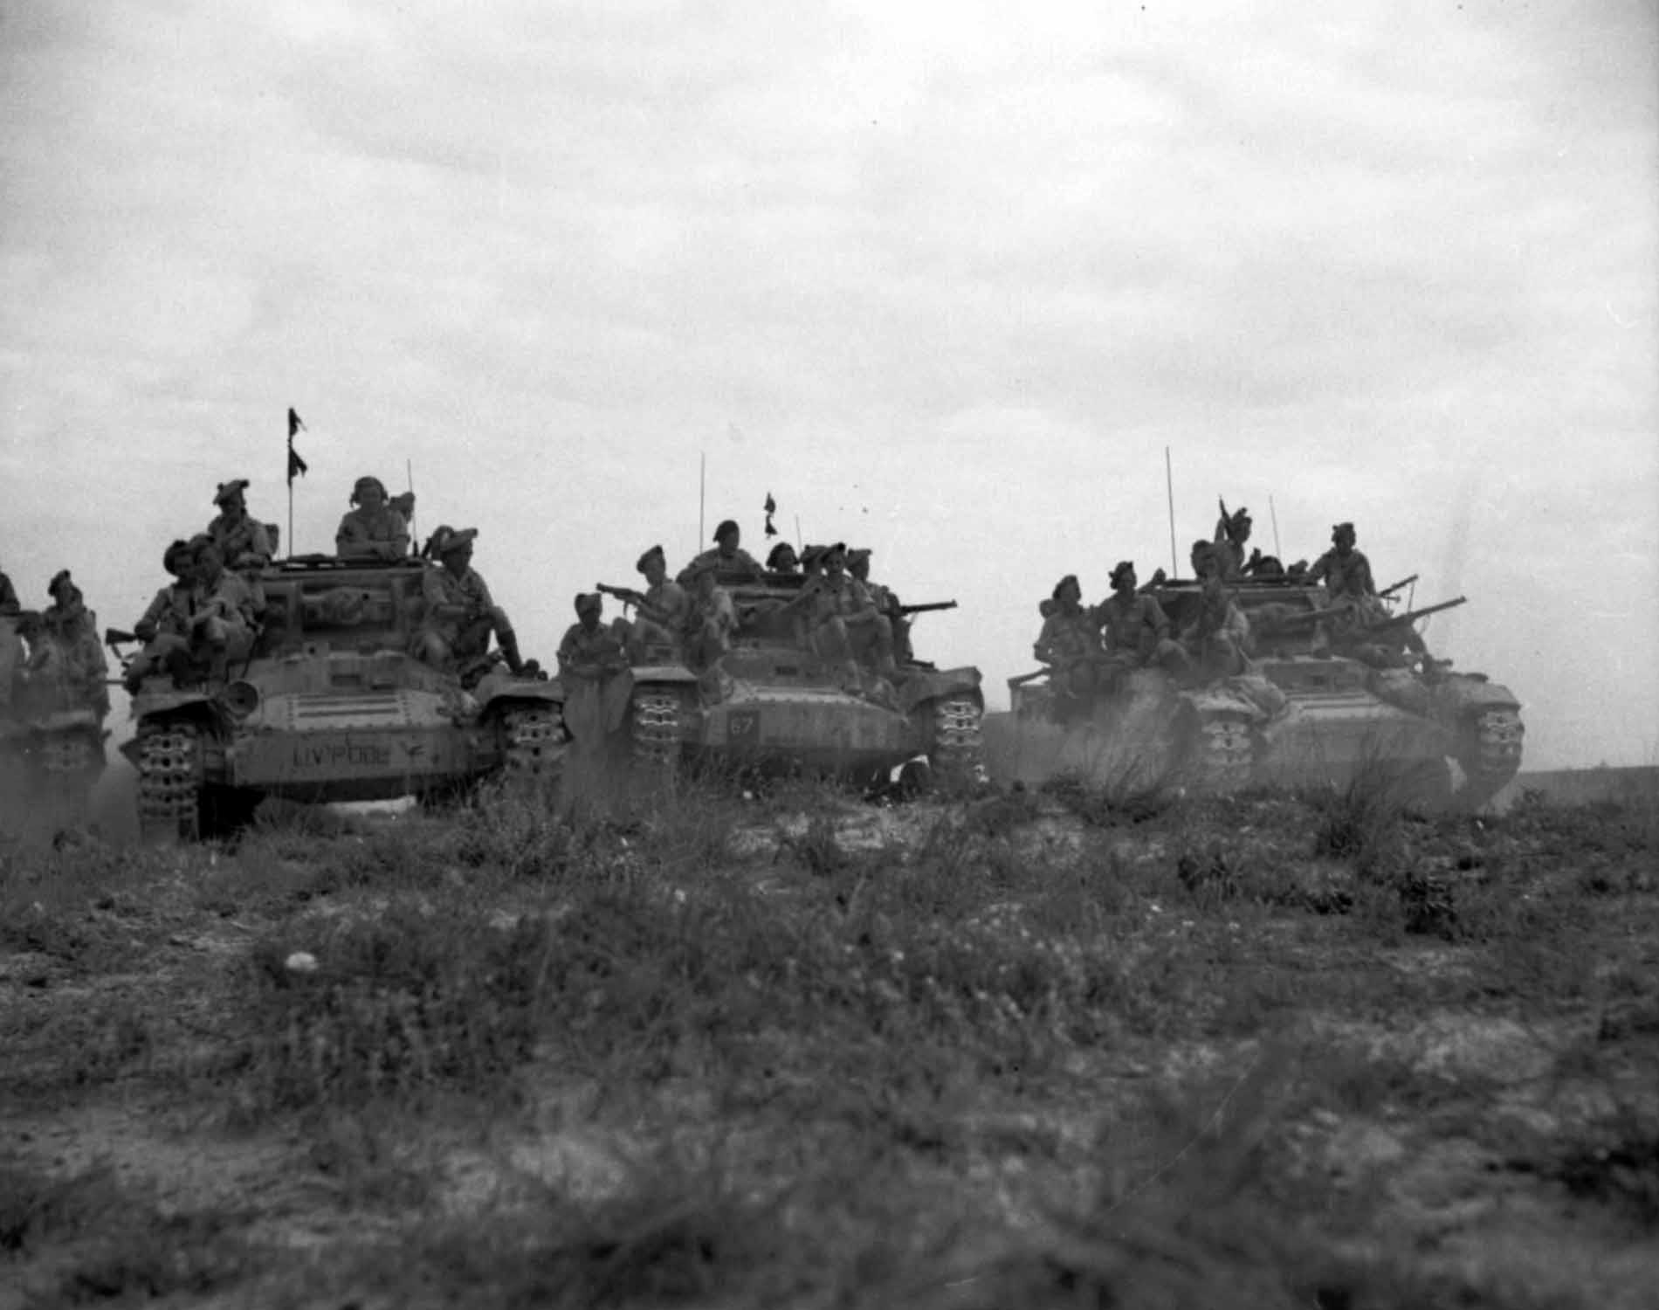
Valentine tanks carrying infantry of the Black Watch, March 1943.
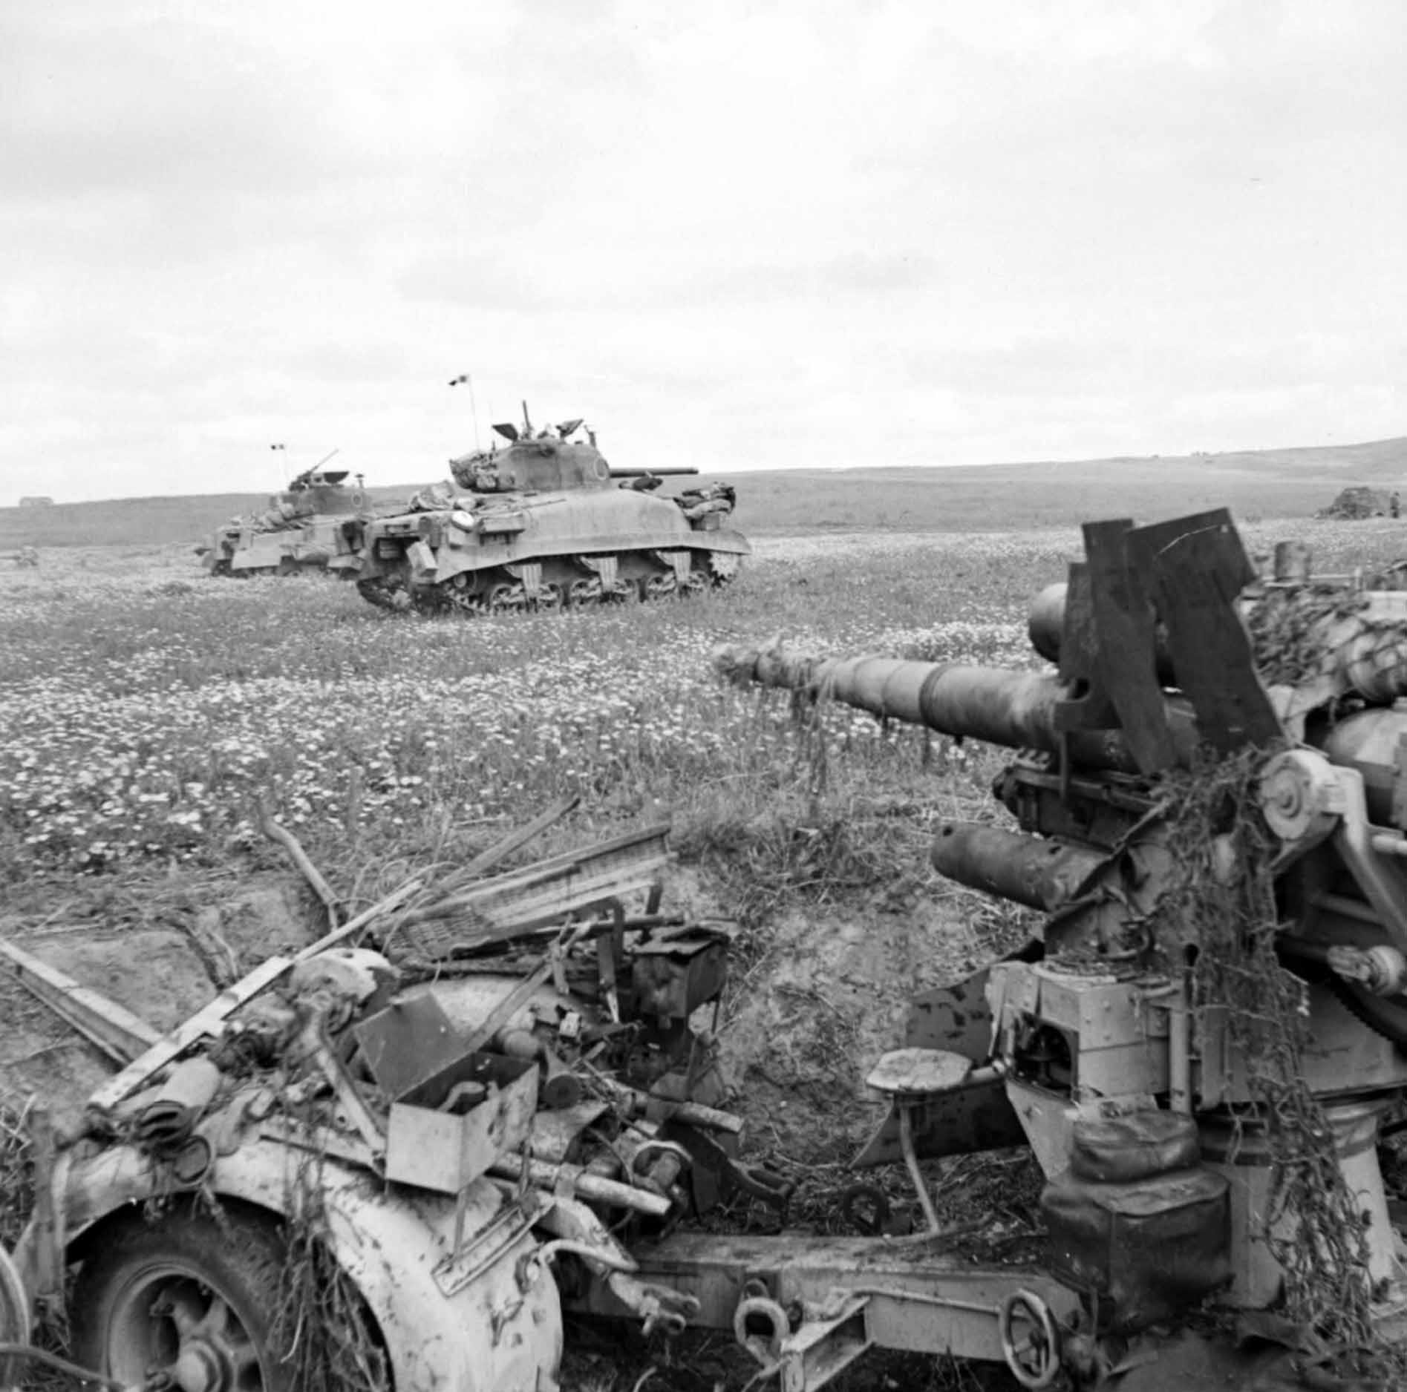
Sherman tanks advance past a knocked-out 88mm anti-tank gun, Tunisia 1943.
The culmination of Montgomery’s ‘Left Hook’ was now approaching. As the infantry, including the Maori Battalion, engaged in fierce battles on the high ground around the Tebaga Gap in Tunisia, the 1st Armoured Division pushed through the positions already seized by the New Zealand Corps, including Bill Close’s unit. British armour was making an unprecedented night manoeuvre through the German lines.
This was a high-risk strategy being led by one of the new men in Montgomery's army, Major General Horrocks¹ who was commanding X Corps. If it all went wrong, they would be sitting in a very vulnerable position in the morning.
I started very bravely with the upper part of my body sticking out of the turret of my tank, but as the advance went on I got lower and lower until only the top of my head was visible. There was too much stuff flying about for comfort, though most of the enemy fire was going over our heads into the area which we had just vacated.
Horrocks accompanied the 1st Armoured Division in his personal command tank:
It was the most exciting and worrying night of my life. As my small tactical HQ, consisting of three tanks, took up its position in the armoured mass, I realised very well that if this attack went wrong, there was no doubt as to whose head would be on the block.
I could hear the arm-chair strategists in their clubs in London saying, ‘Heavens! The man must be mad. Fancy trying to pass one armoured division through an enemy armoured division. And in the dark too.'
Because that was what we were trying to do. And, of course, in the cold light of day, viewed from England, they would be quite right; but in reality it wasn't as mad as it seemed. The Germans as a rule do not react very quickly to something new, and in this attack two new techniques were being tried out.
Never before had they been subjected to such devastating low-level air attacks and they were shaken, or so it seemed. Because the 8th Armoured Brigade, leading the New Zealand assault with their Balaclava charge, had not suffered such heavy casualties as might have been expected.
Then on top of this was the unusual employment of armour by night. All round was the rumbling of tanks, vague shapes looming out of the dusk. I started very bravely with the upper part of my body sticking out of the turret of my tank, but as the advance went on I got lower and lower until only the top of my head was visible. There was too much stuff flying about for comfort, though most of the enemy fire was going over our heads into the area which we had just vacated.
Then suddenly it was dark, and we halted. This was the most trying time of all: we couldn’t even risk that 8th Army panacea for all ills, a brew up. We just had to sit, deep in the enemy positions, and wait.
I got down into the tank to see how my crew, the gunner-operator and driver, were feeling. They were cheerful and completely unimpressed by the fact that they were taking part in a unique military operation: they might in fact have been driving up the long valley at Aldershot. In moments of crisis the phlegm ofthe British soldier is very reassuring.
This long halt seemed to go on for ever: then a pale dusty moon began to make its appearance. And at last, thank goodness, we were off again. It was just possible to make out the dim shape of the tanks in front and on either side and there was a great deal of ill-aimed firing all round.
At times the tanks were crunching over occupied enemy trenches, and we could see terrified parties of Germans and Italians running about with their hands up. But we hadn’t time to bother about prisoners.
At times the tanks were crunching over occupied enemy trenches, and we could see terrified parties of Germans and Italians running about with their hands up. But we hadn’t time to bother about prisoners. Our progress was desperately slow. That was my chief worry. If we didn’t succeed in getting through in the dark, the situation in the morning didn’t bear thinking about. We should be surrounded by the enemy and dominated by the hills on either side of the valley.
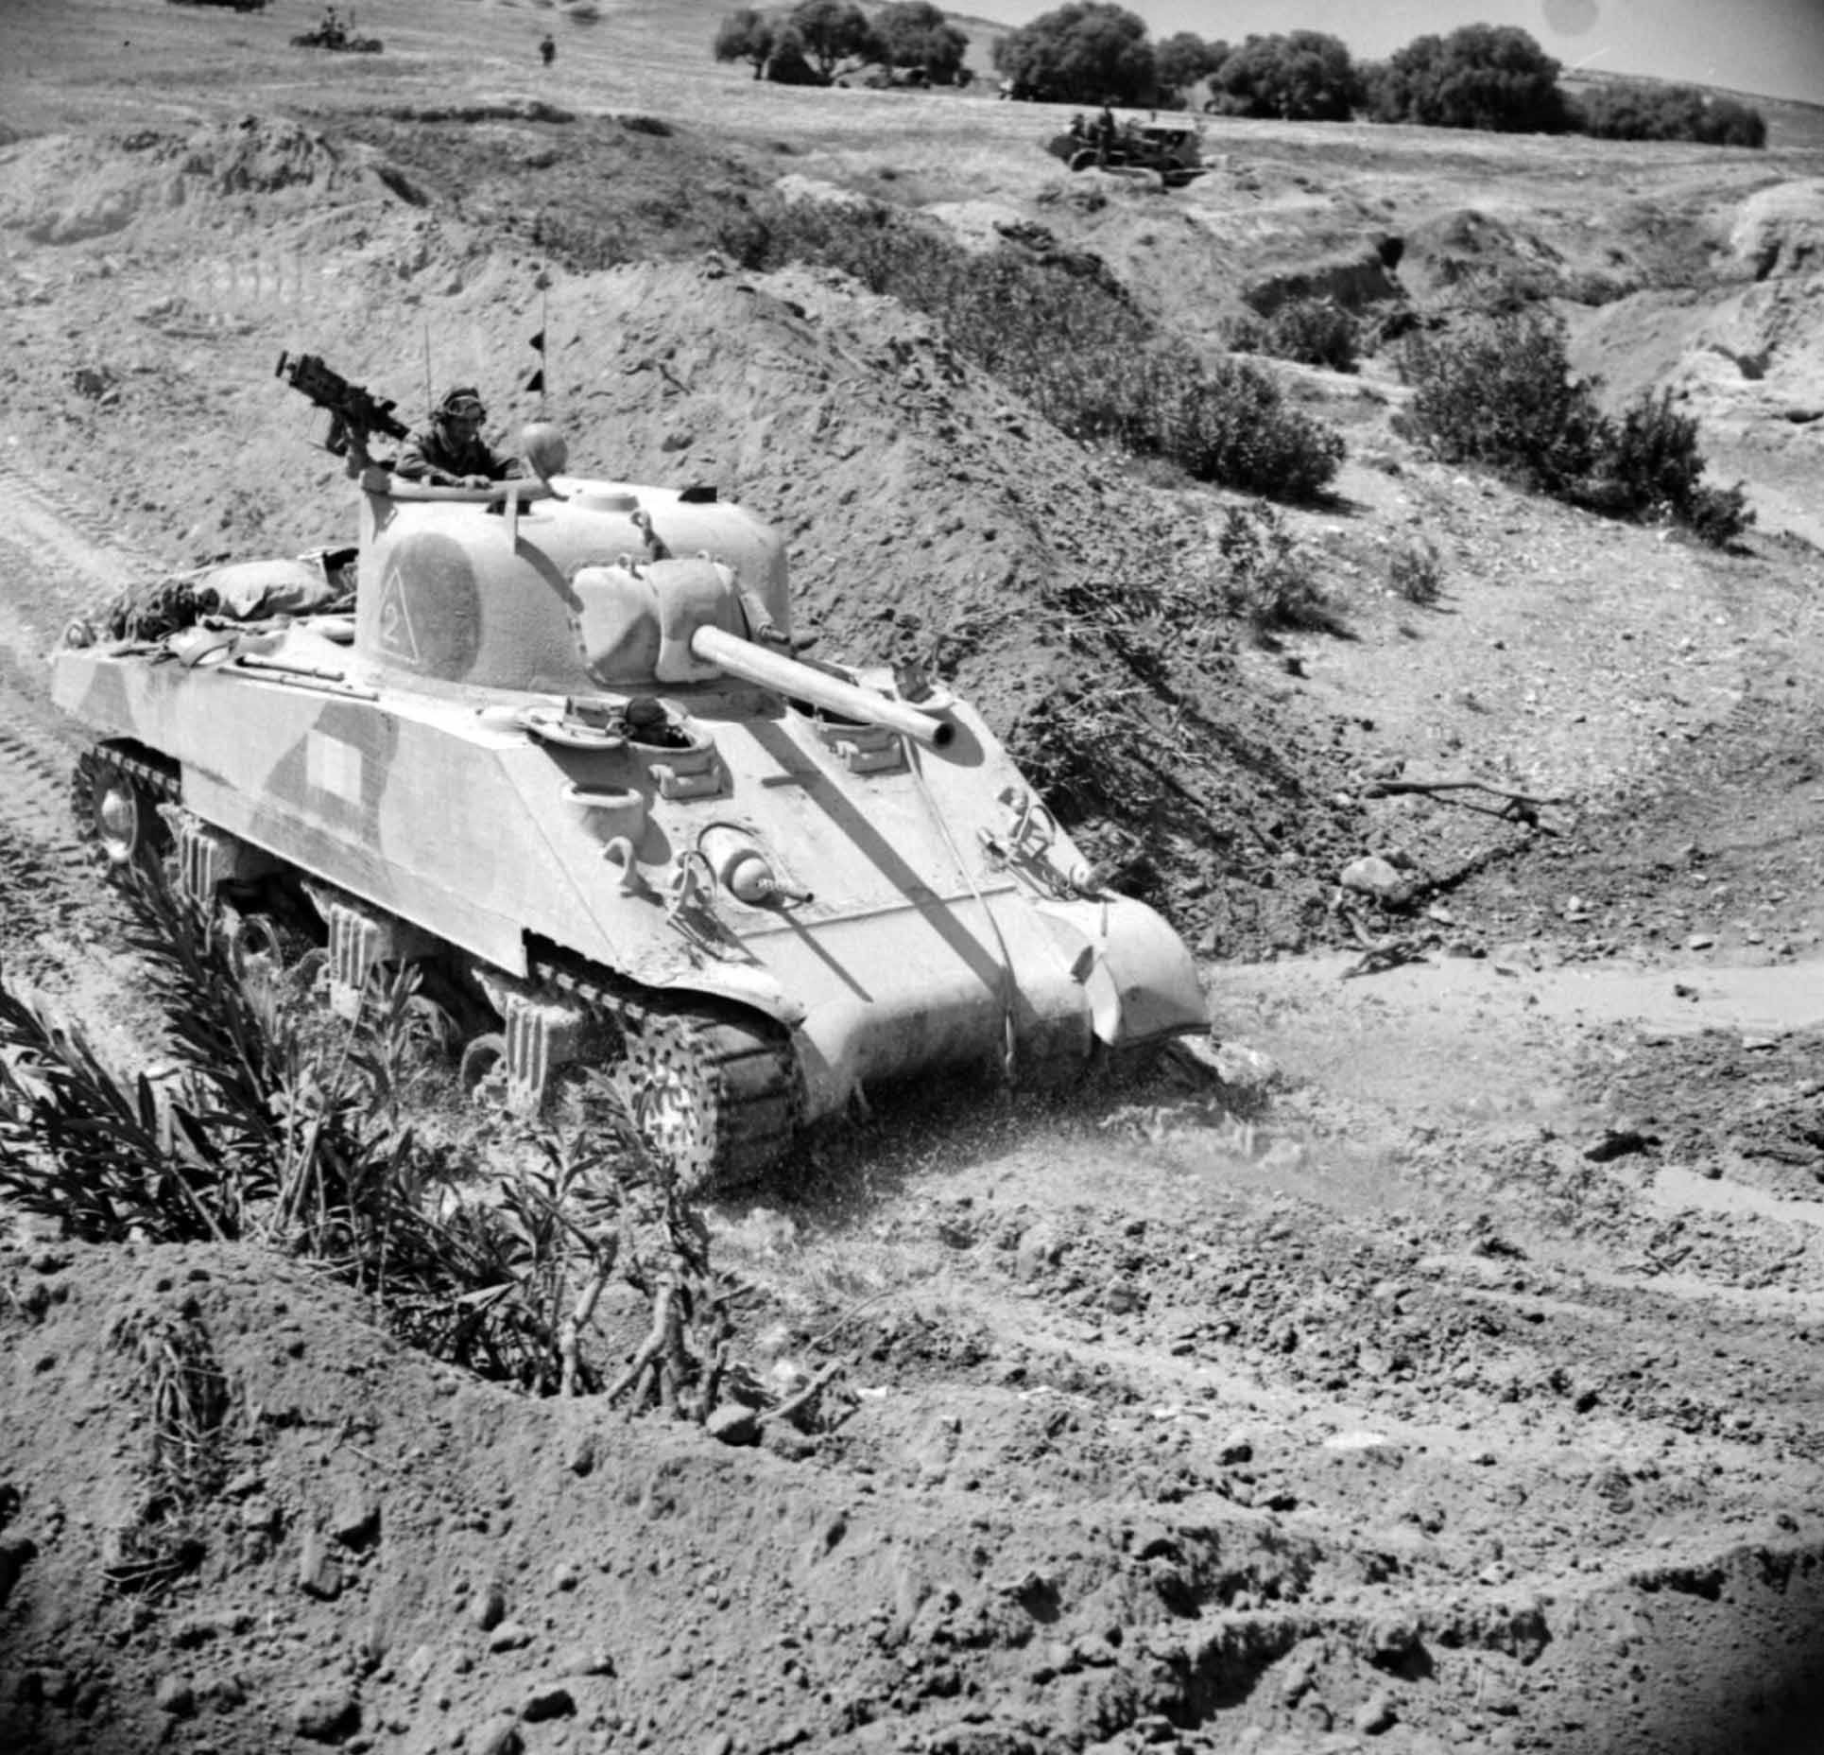
A Sherman tank crossing a wadi whose steep banks had already been breached by bulldozers, Tunisia 1943.
The reason for the continuous halts soon became clear: the valley was intersected by wadis, many of which were tank obstacles, and it was not easy for the leading regiment to find crossing places. Some-times this necessitated getting on to a one-tank front. But we steadily rumbled on and this difficult night advance was brilliantly carried out by the 1st Armoured Division.
As the night wore on the noise of firing came more and more from the rear, and suddenly I realised that we were through - the impossible manoeuvre had come off: It was an unforgettable moment.
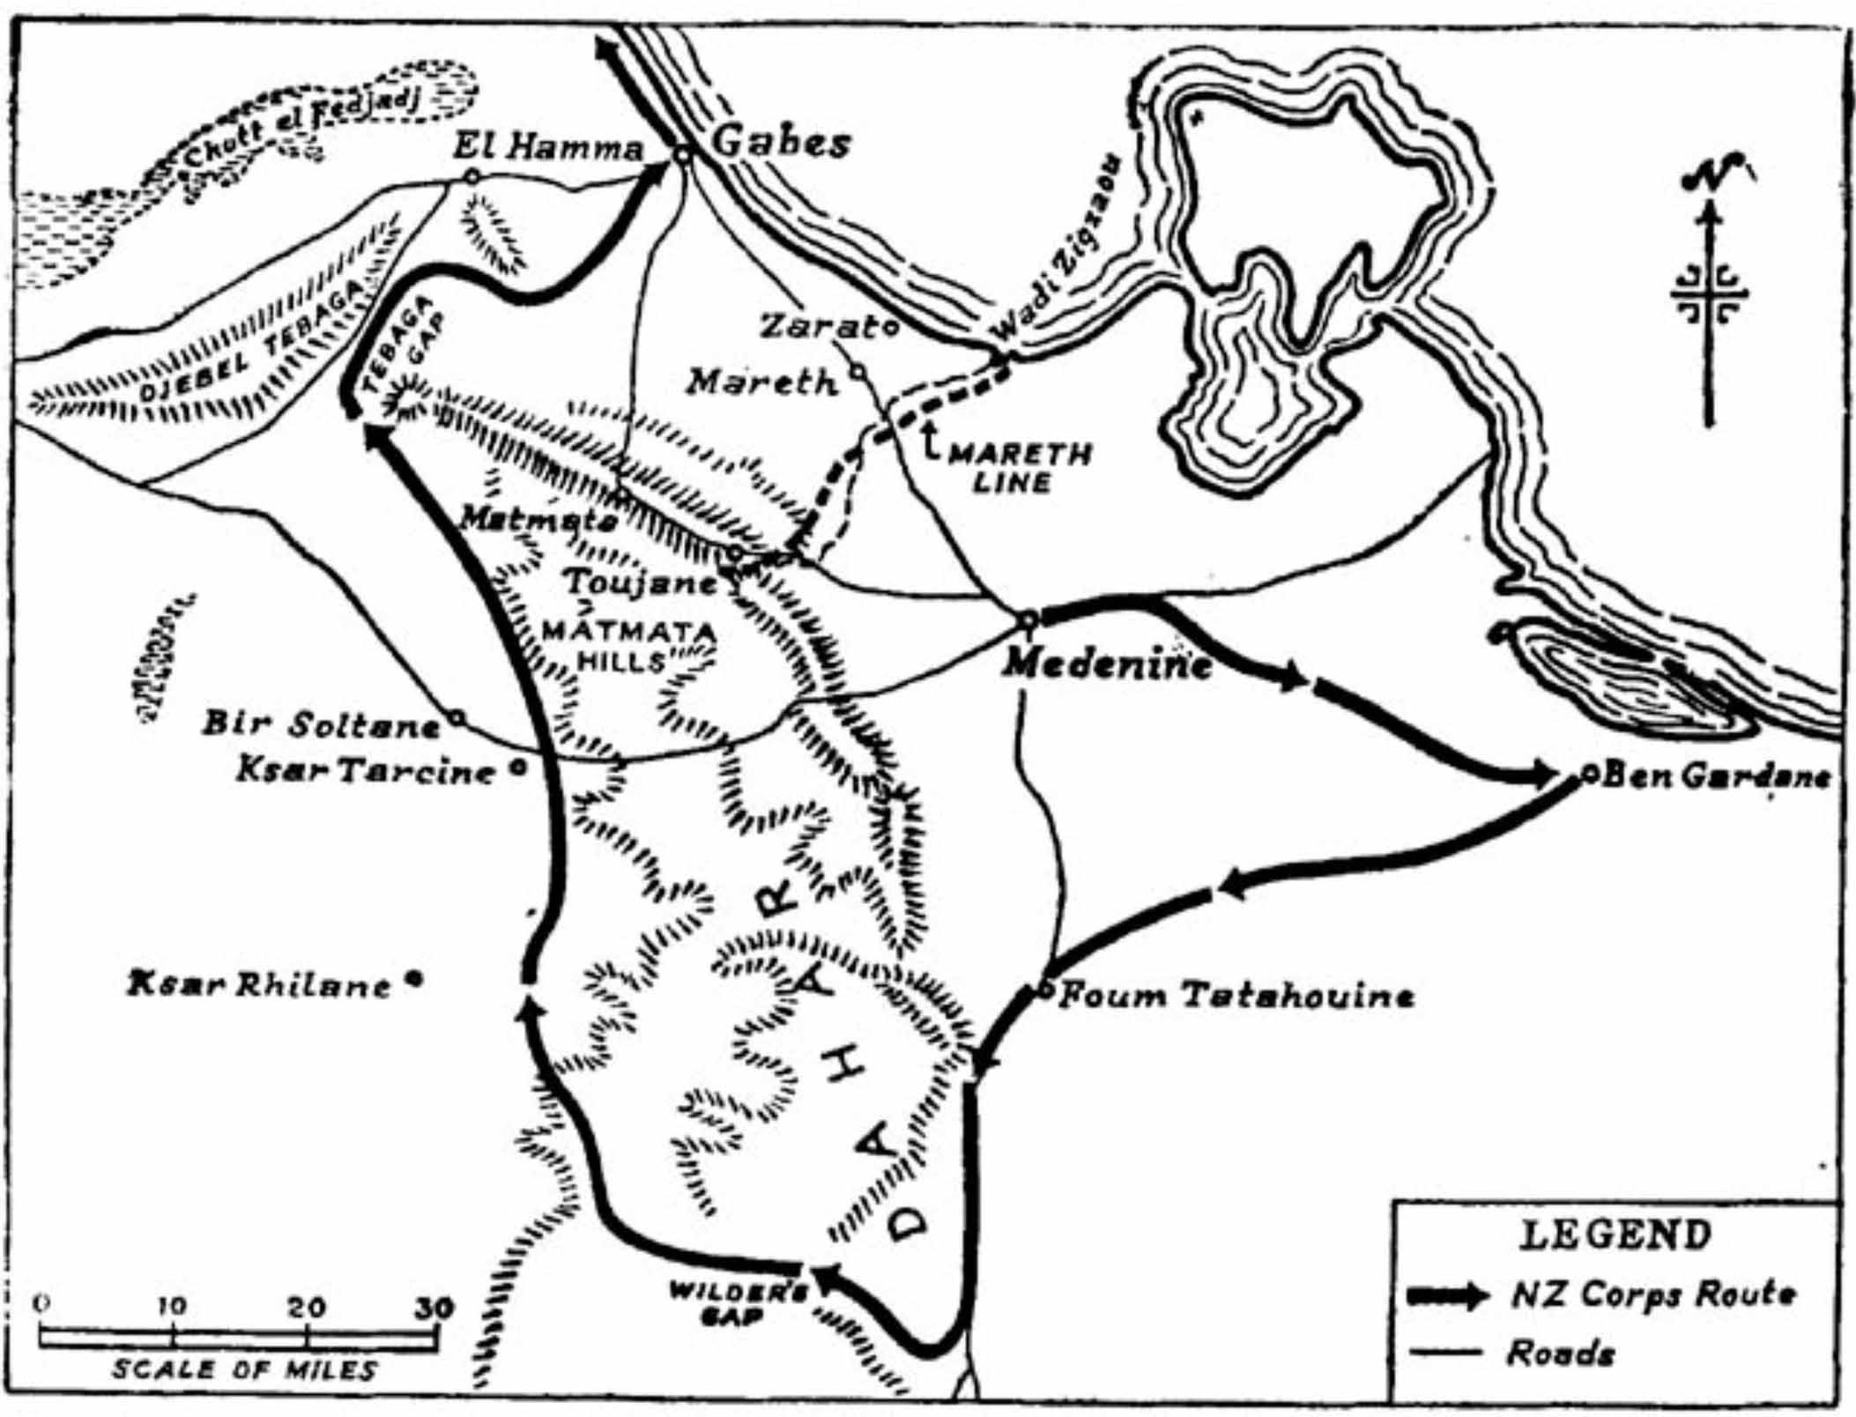
Only by daylight on the 27th March was it clear that they had succeeded. By the end of the day they were at El Hamma, half way to the coast, and had surrounded a large portion of the Italian and German forces and outflanked the Mareth Line defences
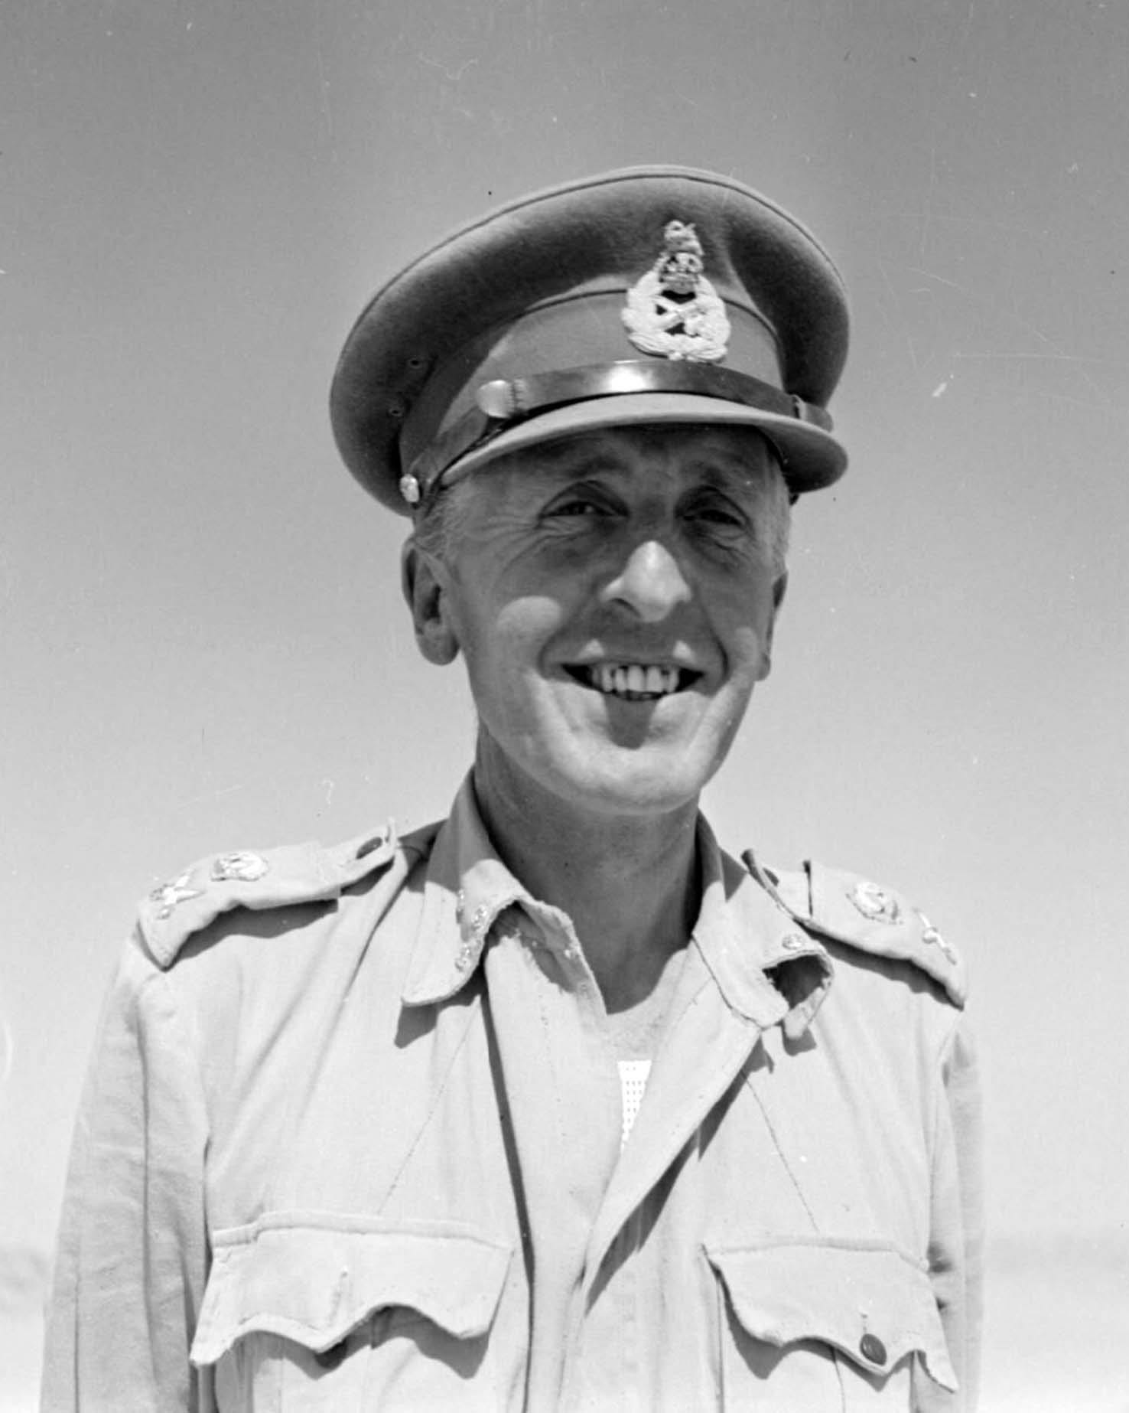
Lieutenant General Sir Brian Horrocks (1895-1985): Portrait of Lieutenant General Horrocks as Commander 13th Corps in North Africa.
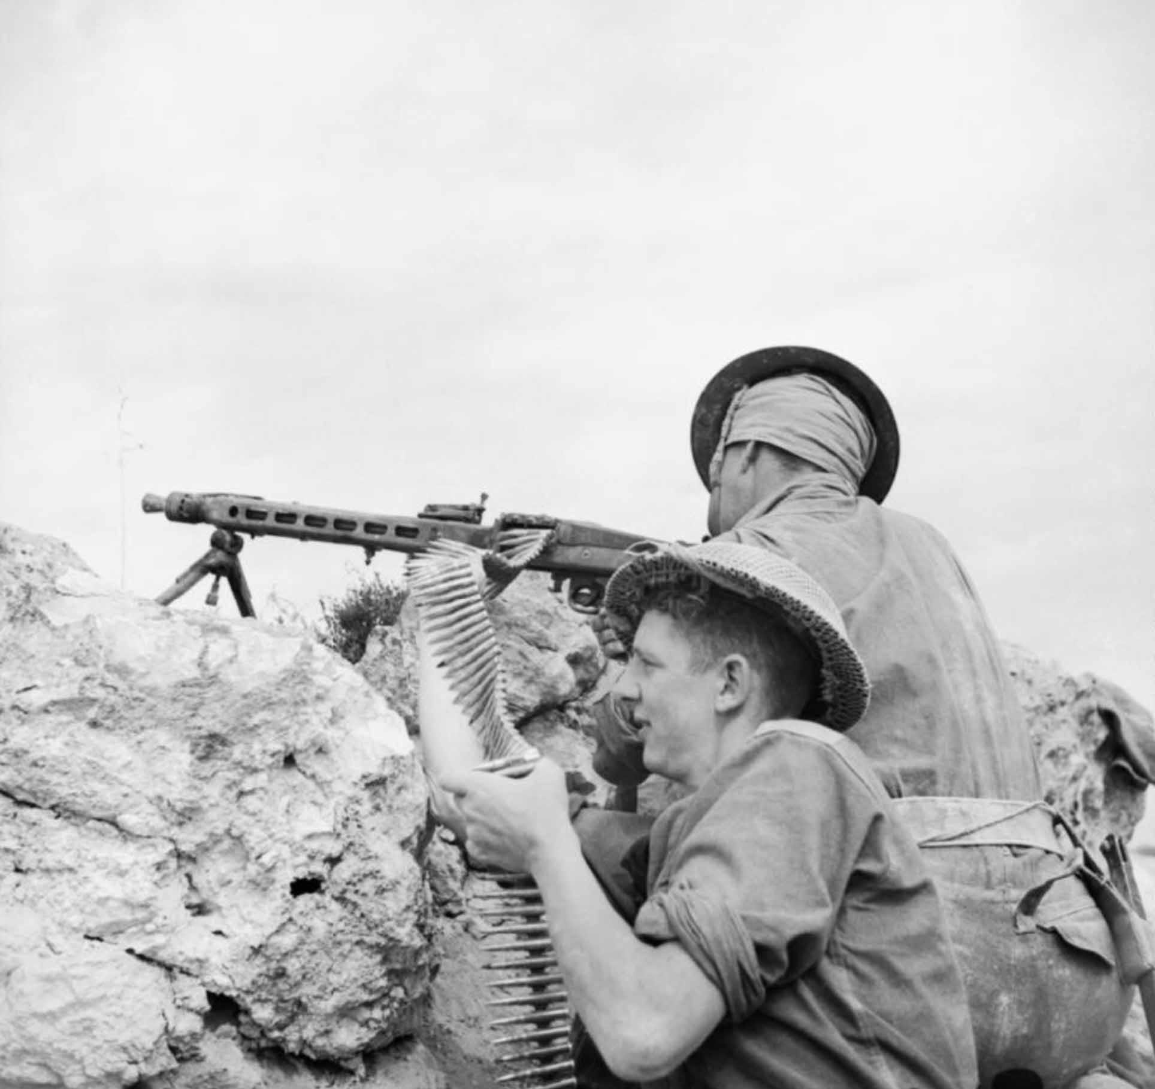
Men of the 2nd Sherwood Foresters firing a captured German MG42 machine gun, 27 April 1943. Found abandoned on the ridge that they had just taken, they turned it on the retreating Germans
1
Sir Brian Horrocks: A Full Life

